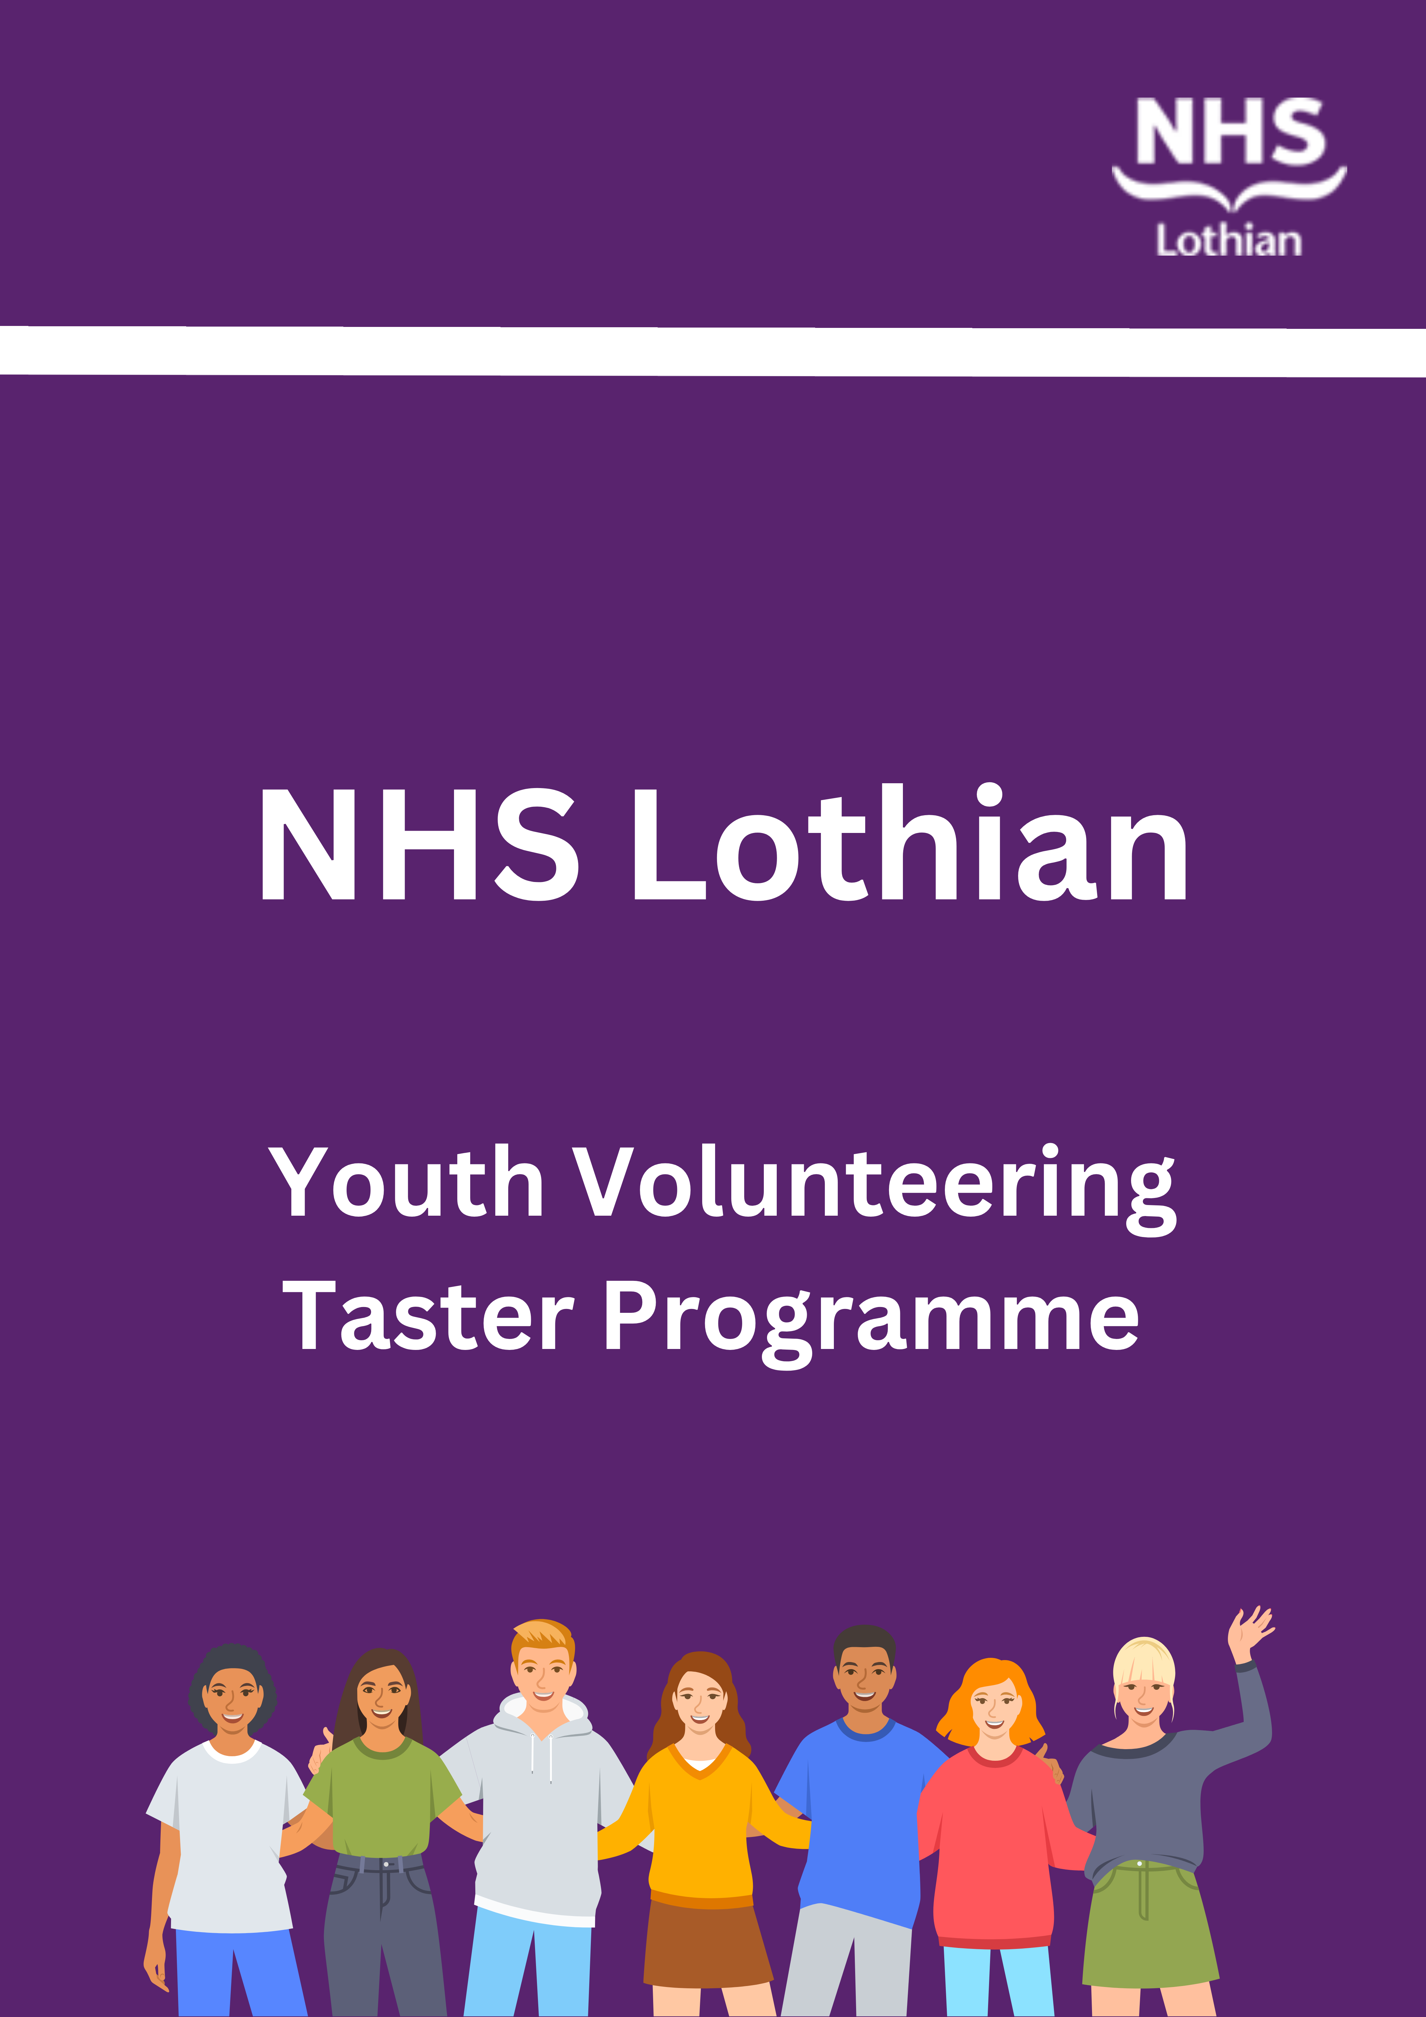
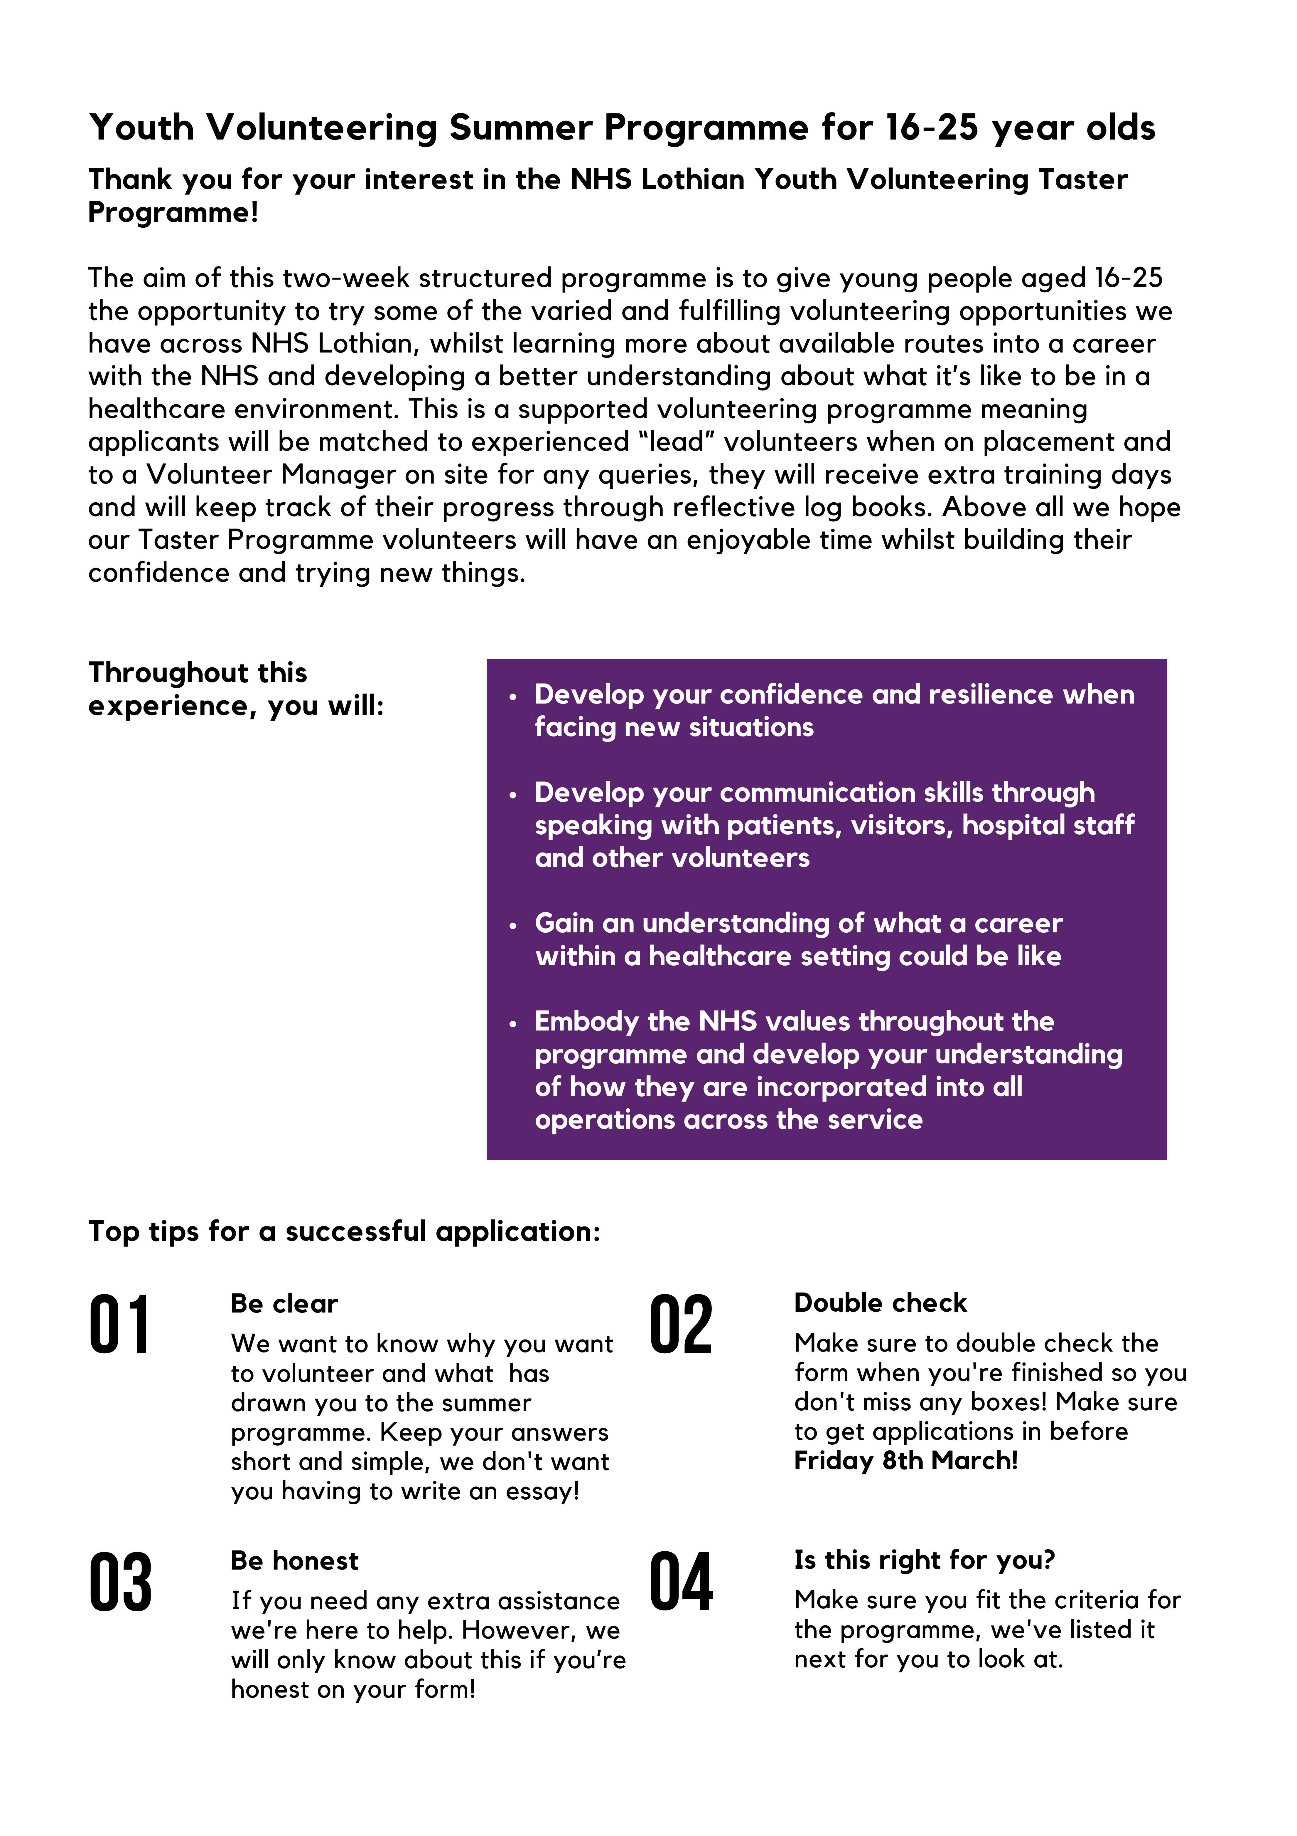

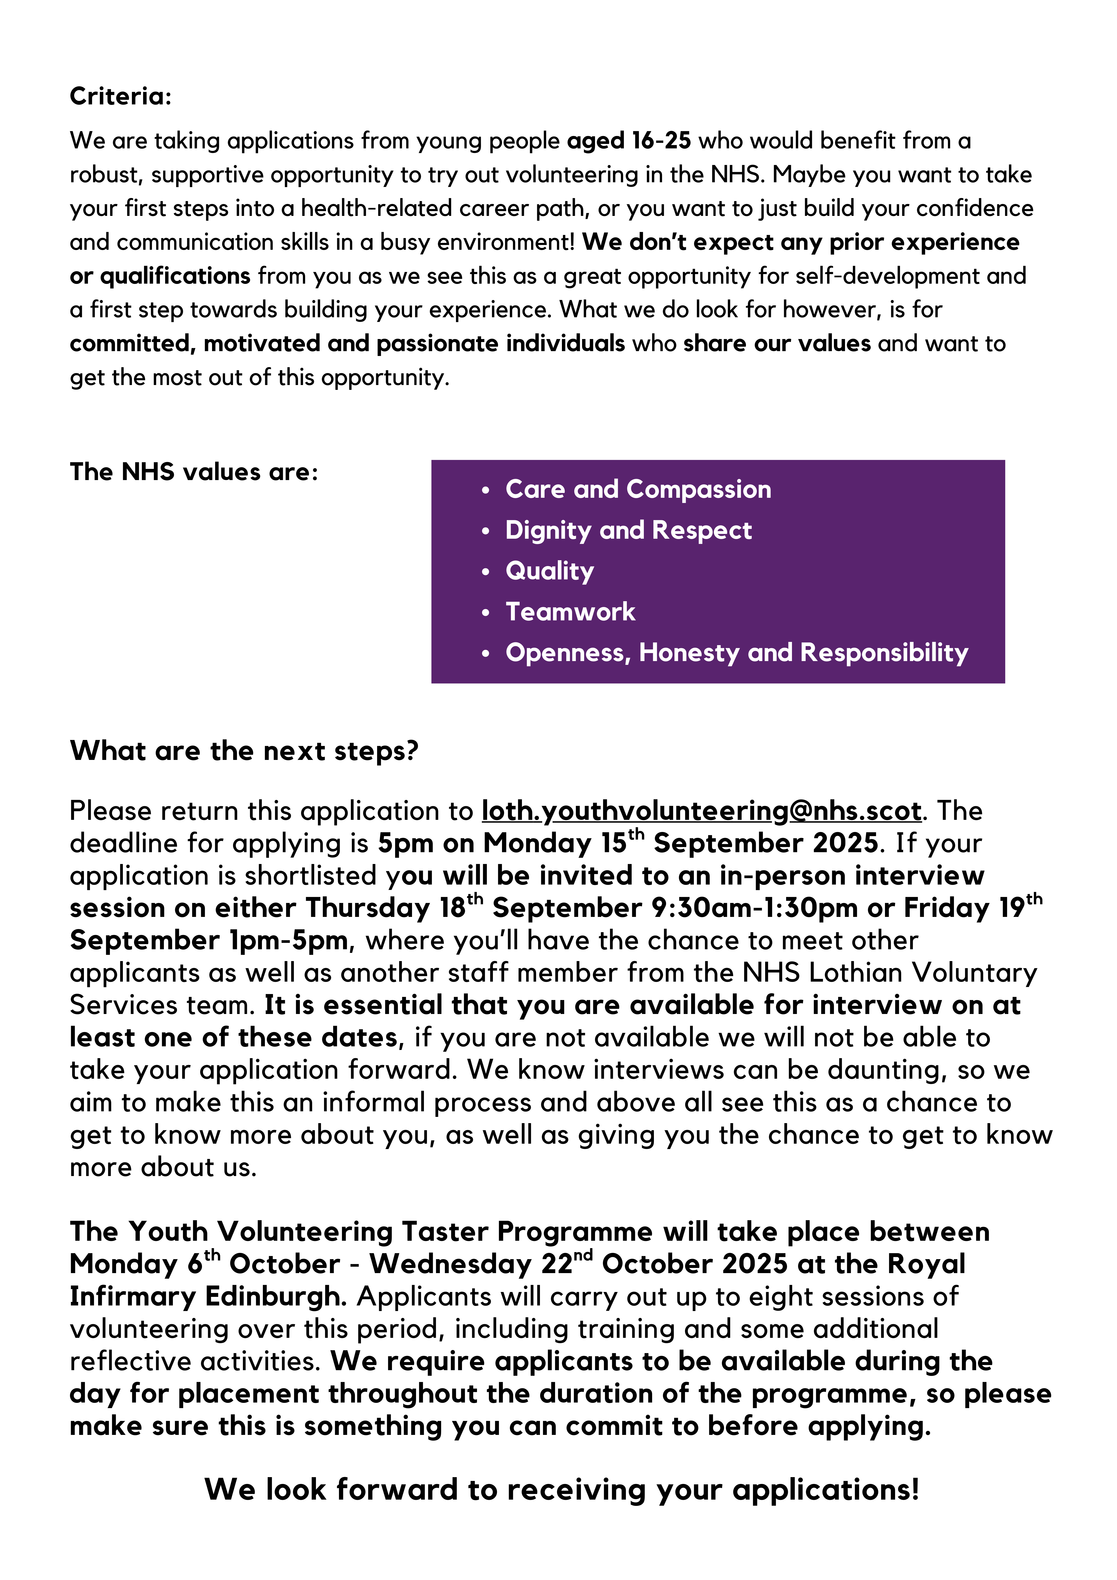
Youth Volunteering Taster Programme (aged 16-25’s)

FAIR TREATMENT STATEMENT
No applicant will be unfairly discriminated against on account of their age, cultural/religious/political belief, disability, ethnicity, gender, race, relationship status, and sexual orientation and/or Trade Union membership/stewardship.

Please return completed form along with a completed occupational health self-declaration form and an equal opportunity form to: loth.meaningfulmay@nhslothian.scot.nhs.uk

PERSONAL DETAILS
Surname:
Forenames: | (Please ensure you use all middle names)
Title: |  | Date of Birth: |  |  | Pronouns (how would you like us to address you?):

CONTACT DETAILS
Address: |  |  |  | Telephone Numbers
Address: |  |  |  | Day:
Address: |  |  |  | Evening:
City/Town: |  |  |  | Mobile:
Post Code: |  | Email:

I confirm I have read the “what are the next steps” paragraph on page 3, and can attend the stated interview dates, and I am flexible to volunteer between Monday 6th – Wednesday 22nd October | (please state yes/no)
I confirm I can travel to the Royal Infirmary Edinburgh to undertake volunteering | (please state yes/no)

Availability - please indicate any days between Monday 6th and Wednesday 22nd October that you would not be able to volunteer

Emergency Contacts - please include contact details for your guidance teacher (if still attending school) or support worker, and your emergency contact
Name of guidance teacher (if still attending school): |  | Phone number:
Email address: |  | Phone number:
Name of emergency contact and relationship to you (e.g mother, guardian): |  | Phone number:
Email address: |  | Phone number:

Tell us a little bit about you? (How do you spend your time, what are your interests, etc?)

Why do you want to join the Youth Volunteering Taster Programme? (What are your motivations for applying, what do you hope to gain from it, etc?)

Can you give two examples of times when you have displayed the NHS values? (Please pick one from the following list for each example: Care and Compassion, Dignity and Respect, Quality, Teamwork, and Openness Honesty and Responsibility. More on the values here: https://org.nhslothian.scot/OurValues/Pages/default.aspx)
Value 1 (please state your first value):
Please provide your example here:
Value 2 (please state your first value):
Please provide your example here:

Are there any circumstances that you’re aware of that might impact in your ability to take part in the programme? (This will not affect your chances of recruitment, it’s just so we can make sure we are supporting you as best as we can!)

Volunteering is a big commitment. What plans or support do you have in place to help you to volunteer? We ask each of our volunteers to make a commitment to attend up to eight different sessions throughout the programme, including training days. This placement will be in the Royal Infirmary and the volunteering sessions may begin as early as 9:30am. Tell us a little bit about how you will manage to fit in volunteering with other commitments you may have and any arrangements you have in place to ensure you will make your placement on time each day (i.e. regular bus/reliable transport options you have, how you will manage your time, any experience of timekeeping you already have)

Tell us about any personal traits, skills or characteristics you have which would make you a good volunteer (anything you haven’t had the chance to write about yet that you feel would be beneficial for us to know or any other characteristics or skills you already possess which might be beneficial in the volunteering role)
Remember to read, complete and sign the final page of the form.

Reference from someone who knows you well - Please ask someone who knows you well (but is not a family member or friend) to write a few words in support of your application to volunteer. This could be a teacher, a support worker, an employer/volunteer manager or anyone you know in a more formal way.
Name: | Occupation:
How do you know the potential volunteer:
Please provide comment on the potential volunteer’s suitability to volunteer with NHS Lothian (if possible make reference to how you think they might benefit from volunteering, their values and character, their ability to make the required commitment and any support you may be able to provide to help them as they volunteer).

Signature: | Date:

FOOTNOTES AND DECLARATIONS
Footnote (1)
Criminal Convictions
Having a criminal record will not necessarily stop you from volunteering with NHS Lothian. This will depend on the nature of the role, together with the circumstances and background of the offence(s).
In September 2015 the Scottish Government made changes about what conviction information needs to be disclosed. [Some offences must always be disclosed, some offences do not need to be disclosed and some offences must be disclosed in specified circumstances.] The rules are complicated, so it is important you read the guidance below as part of making your application to volunteer. NHS Scotland is exempt from the 1974 Rehabilitation of Offenders Act (Exclusions & Exceptions) (Scotland) Order 2003.
As part of any volunteering role applicants will be subject to one of the following:
- For roles in regulated activity – Protection of Vulnerable Groups Scheme membership.
- For all other roles which are subject to a criminal conviction record check – A Police Act check.
- For roles not subject to a criminal conviction record check – A self-declaration
For more information on the rules visit: Disclosing criminal convictions rules
For more information on offences which must always be disclosed: Always Disclose List
For more information on offences which are to be disclosed subject to rules: Offences subject to rules

Footnote (2)
Data Protection Legislation
In processing any personal information or data we hold about you we will comply with the requirements of Data Protection Legislation. In particular all reasonable steps will be taken to ensure data is processed fairly, kept secure, protected against loss or damage & only disclosed (unless required by law or legal process) on a need-to-know basis. Under the Legislation you are entitled to ask us to provide copies of certain data we hold about you.

DECLARATION
I have completed of this application form and the details I have supplied are, to the best of my knowledge, true and complete.
I understand that if appointed to this post the information on this form will be kept as part of my personal file record.
I authorise NHS Lothian to obtain references in support this application.
I understand that NHS Lothian require the details included in this form which will only be used for specific and lawful purposes as stated in Data Protection Legislation. This information will be held in accordance with NHS Lothian’s policies regarding confidentiality and data security.
I agree to complete a criminal convictions check or a criminal convictions declaration form, if I am identified as a suitable volunteer.
Read, agreed and understood (check box)
Signature: |  | Date:

DISABILITY (Place an X in the appropriate box)
The Disability Discrimination Act 1995 and Amended Regulations 2005 define disability as follows: “any physical or mental impairment which has a substantial adverse effect on a person’s ability to carry out normal day to day activities”. NHS Scotland is “Positive about disabled people”, and as such we provide job opportunities for disabled people.
NHS Scotland operates an Interview Guarantee scheme, which means that if you have a disability, and meet the minimum criteria and availability outlined on page 3, you will be guaranteed a volunteer interview. However, some disabled people prefer not to take this option, so please tick your preference if you are a disabled candidate.
Do you want to participate in the Guarantee Scheme? Yes No

