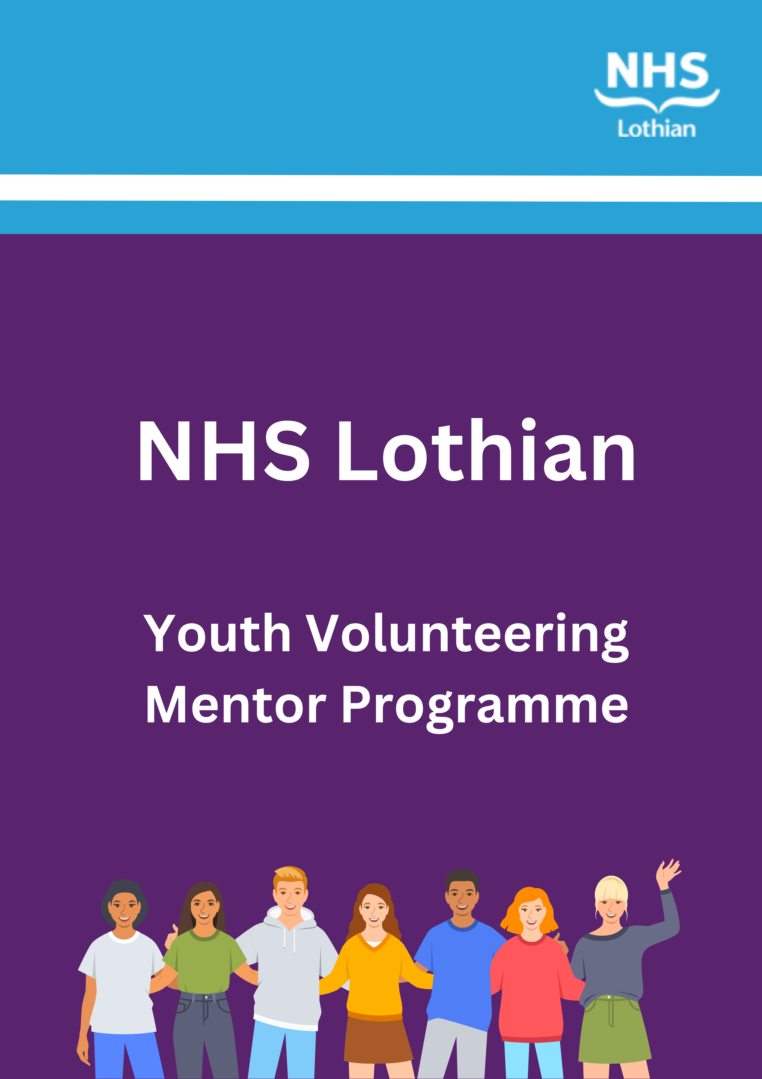
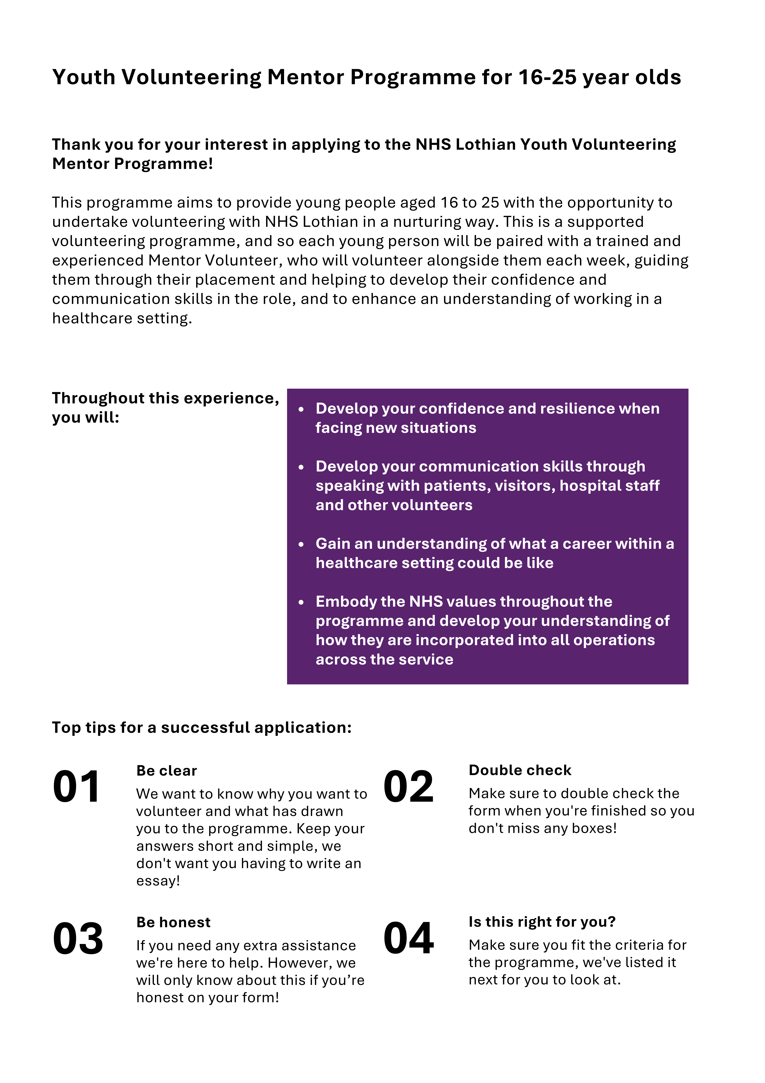

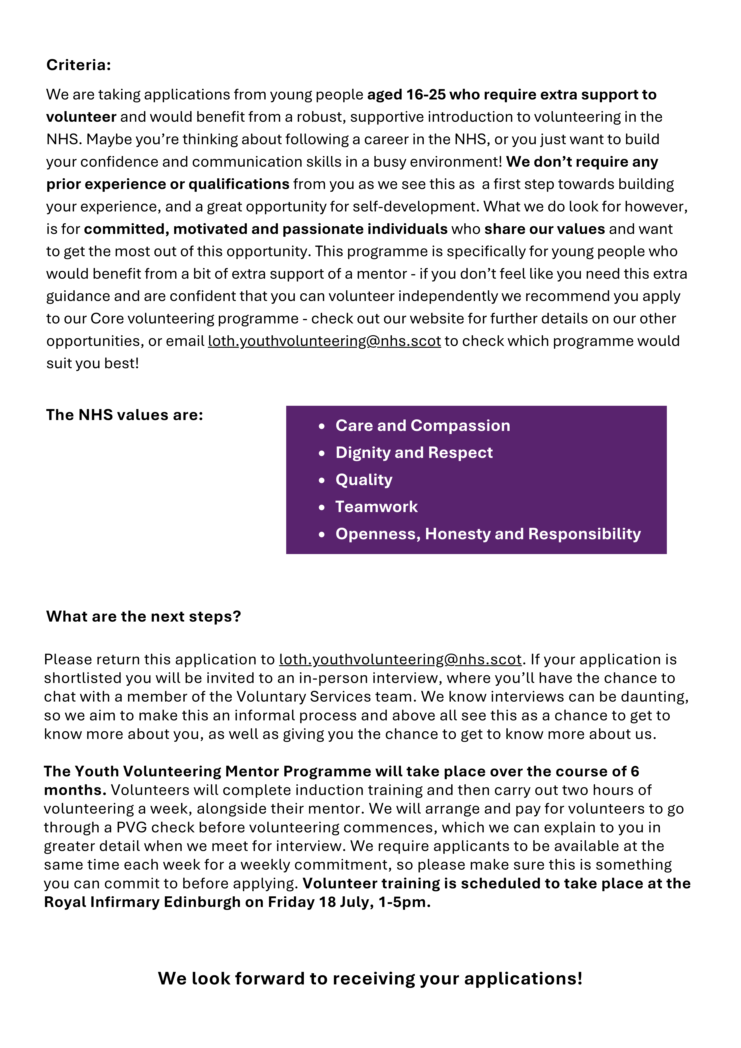
Youth Volunteering Mentor Programme (aged 16-25’s)

FAIR TREATMENT STATEMENT
No applicant will be unfairly discriminated against on account of their age, cultural/religious/political belief, disability, ethnicity, gender, race, relationship status, and sexual orientation and/or Trade Union membership/stewardship.

Please return completed form along with a completed occupational health self-declaration form and an equal opportunity form to: loth.youthvolunteering@nhs.scot

PERSONAL DETAILS
Surname:
Forenames: | (Please ensure you use all middle names)
Title: |  | Date of Birth: |  |  | Pronouns (how would you like us to address you?):

CONTACT DETAILS
Address: |  |  |  | Telephone Numbers
Address: |  |  |  | Day:
Address: |  |  |  | Evening:
City/Town: |  |  |  | Mobile:
Post Code: |  | Email:

Preference of NHS site - unfortunately, there is a limited number of opportunities at each site which means we might not be able to accommodate the preferences of all applicants.
Site | I am able to travel there (please tick all that apply) | Please indicate 1st, 2nd and 3rd preference
East Lothian Community Hospital (Haddington)
St John’s Hospital (Livingston)
Royal Infirmary Edinburgh
Midlothian Community Hospital
Western General Hospital (Crewe Road South)

Availability - please indicate days or times of the week (if any) that you would be unable to volunteer on (Mon-Fri)

Emergency Contacts
Name of guidance teacher (if still attending school): |  | Phone number:
Email address: |  | Phone number:
Name of emergency contact and relationship to you (e.g mother, guardian): |  | Phone number:
Email address: |  | Phone number:
Tell us a little bit about you? (How do you spend your time, what are your interests, etc?)

Why do you feel you would benefit from the support of a Volunteer Mentor? (What are your motivations for applying, what do you hope to gain from the mentoring programme, etc?)

Can you give two examples of times when you have displayed the NHS values? (Please pick one from the following list for each example: Care and Compassion, Dignity and Respect, Quality, Teamwork, and Openness Honesty and Responsibility. More on the values here: https://org.nhslothian.scot/OurValues/Pages/default.aspx)
Value 1 (please state your first value):
Please provide your example here:
Value 2 (please state your first value):
Please provide your example here:

Are there any circumstances that you’re aware of that might impact in your ability to take part in the programme? (This will not affect your chances of recruitment, it’s just so we can make sure we are supporting you as best as we can!)

Volunteering is a big commitment. What plans or support do you have in place to help you to volunteer? We ask each of our volunteers to make a commitment to attend two hours a week, on the same day each week. Where you’ll volunteer alongside your mentor. Tell us a little bit about how you will manage to fit in volunteering with any other commitments you may have and any arrangements you have in place to ensure you will make your placement on time each day (i.e. regular bus/reliable transport options you have, how you will manage your time, any experience of timekeeping you already have)

Tell us about any personal traits, skills or characteristics you have which would make you a good volunteer (anything you haven’t had the chance to write about yet that you feel would be beneficial for us to know or any other characteristics or skills you already possess which might be beneficial in the volunteering role)
Remember to read, complete and sign the final two pages of the form.

FOOTNOTES AND DECLARATIONS
Footnote (1)
Criminal Convictions
Having a criminal record will not necessarily stop you from volunteering with NHS Lothian. This will depend on the nature of the role, together with the circumstances and background of the offence(s).
In September 2015 the Scottish Government made changes about what conviction information needs to be disclosed. [Some offences must always be disclosed, some offences do not need to be disclosed and some offences must be disclosed in specified circumstances.] The rules are complicated, so it is important you read the guidance below as part of making your application to volunteer. NHS Scotland is exempt from the 1974 Rehabilitation of Offenders Act (Exclusions & Exceptions) (Scotland) Order 2003.
As part of any volunteering role applicants will be subject to one of the following:
- For roles in regulated activity – Protection of Vulnerable Groups Scheme membership.
- For all other roles which are subject to a criminal conviction record check – A Police Act check.
- For roles not subject to a criminal conviction record check – A self-declaration
For more information on the rules visit: Disclosing criminal convictions rules
For more information on offences which must always be disclosed: Always Disclose List
For more information on offences which are to be disclosed subject to rules: Offences subject to rules

Footnote (2)
Data Protection Legislation
In processing any personal information or data we hold about you we will comply with the requirements of Data Protection Legislation. In particular all reasonable steps will be taken to ensure data is processed fairly, kept secure, protected against loss or damage & only disclosed (unless required by law or legal process) on a need-to-know basis. Under the Legislation you are entitled to ask us to provide copies of certain data we hold about you.

DECLARATION
I have completed of this application form and the details I have supplied are, to the best of my knowledge, true and complete.
I understand that if appointed to this post the information on this form will be kept as part of my personal file record.
I authorise NHS Lothian to obtain references in support this application.
I understand that NHS Lothian require the details included in this form which will only be used for specific and lawful purposes as stated in Data Protection Legislation. This information will be held in accordance with NHS Lothian’s policies regarding confidentiality and data security.
I agree to complete a criminal convictions check or a criminal convictions declaration form, if I am identified as a suitable volunteer.
Read, agreed and understood (check box)
Signature: |  |  |  |  | Date:
REFERENCES
It is a requirement to supply two professional references, or one professional reference and one character reference. As an example, a professional reference can be a previous/current employer, colleague, volunteering manager, teacher, support worker, doctor/healthcare professional, minister of religion, or club official. A character reference can be provided by someone who knows you in a professional capacity or a previous/current neighbour or family friend. You should NOT use family members.
If you are over the age of 18 and have lived outside of the UK for 12 consecutive months or more in the last 5 years, please make sure your referees are from the country(s) you have lived during this time.
We recommend that you notify your referees in advance that we may choose to send this request. We normally collect references by email in the first instance.
As a reminder, the purpose of collecting references is to determine your character and suitability for the post you have applied for.
Please note references will not routinely be requested, however NHS Lothian reserves the right to contact references as/when needed.
Referee (1) |  |  | Referee (2)
Name: |  |  | Name:
Relationship to you: |  |  | Relationship to you:
Address: |  |  | Address:
City: |  |  | City:
Postcode: |  |  | Postcode:
Telephone: |  |  | Telephone:
Email: |  |  | Email:

DISABILITY (Place an X in the appropriate box)
The Disability Discrimination Act 1995 and Amended Regulations 2005 define disability as follows: “any physical or mental impairment which has a substantial adverse effect on a person’s ability to carry out normal day to day activities”. NHS Scotland is “Positive about disabled people”, and as such we provide job opportunities for disabled people.
NHS Scotland operates an Interview Guarantee scheme, which means that if you have a disability, and meet the minimum criteria outlined within the role description, you will be guaranteed a volunteer interview. However, some disabled people prefer not to take this option, so please tick your preference if you are a disabled candidate.
Do you want to participate in the Guarantee Scheme? Yes No

